Final Project Report
Online Learning Engagement Analytics
Project Title | Online Learning Engagement and Student Performance Analysis
Team ID | Master Of Computer Applications
Date | 21 September 2026
Tools Used | My SQL, Power BI
Dataset | Online education dataset

Contents
1. Introduction
1.1 Project overview
1.2 Objectives
2. Project Initialization and Planning Phase
2.1 Define Problem Statement
2.2 Project Proposal (Proposed Solution)
2.3 Initial Project Planning
3. Data Collection and PreProcessing Phase
3.1 Data Collection Plan and Raw Data Sources Identified
3.2 Data Quality Report
3.3 Data Exploration and Preprocessing
4. Data Visualization
4.1 Framing Business Questions
4.2 Developing Visualizations
5. Dashboard
5.1 Dashboard Design Screenshot with Insights
6. Report
6.1 Report Design Screenshot with Insights
7. Performance Testing
7.1 Utilization of Data Filters
7.2 No of Calculation Columns/Measures
7.3 No of Visualization
8. Conclusion/Observation
9. Future Scope
10. Appendix
10.1 Source Code (if any)
10.2 GitHub & Project Demo Link

1. Introduction

1.1 Project overview
Online learning platforms record large amounts of student activity and results, but this data is rarely turned into a clear picture of who is engaged, who is struggling and who is likely to drop out. The Online Learning Engagement Analytics project addresses this by analysing student data from the online education dataset table and presenting the findings in an interactive Power BI dashboard and report.
The project covers the full development cycle: problem definition, data collection, SQL analysis, Power BI data preparation, visualization, dashboard development, report creation and performance testing. It examines student engagement (total clicks and engagement level), performance (average score and performance level), risk level, pass and dropout outcomes, and differences by region and educational background.

1.2 Objectives
• Measure the overall picture: total students, average score, average clicks, students who passed and students who dropped out.
• Show how students are distributed across engagement, performance and risk levels.
• Examine how engagement, especially total clicks, relates to average score.
• Identify the engagement and performance groups with the highest dropout rates.
• Compare regions and educational backgrounds on student numbers, scores and activity.
• Deliver an interactive dashboard and report that instructors and program managers can use to decide where to focus support.

2. Project Initialization and Planning Phase

2.1 Define Problem Statement
The customer problem statements below describe the problem from the point of view of the two main users of the dashboard.
 | PS-1 | PS-2
I am (Customer) | An online course instructor | An academic program manager
I’m trying to | identify students who are losing interest before they drop out | understand which student groups are most likely to drop out or fail
But | activity varies widely and its link to scores is unclear | dropout and pass results are hard to compare by region
Because | activity data is not summarised by engagement or performance level | the data sits in a raw table, not in one dashboard
Which makes me feel | worried and unable to step in early enough | uncertain about where to focus support and resources

2.2 Project Proposal (Proposed Solution)
The proposed solution is an end-to-end analytics workflow that turns the raw student table into decisions. SQL queries answer the core questions, Power BI prepares the data and builds the visuals, and a dashboard and report present the results to non-technical users.
Component | Description
Data source | Online education dataset: one table with student activity, score, engagement, risk, pass and dropout fields.
SQL analysis | Thirteen queries covering KPIs, engagement, performance, risk, dropout, region and educational background (see Appendix 10.1).
Power BI data preparation | Load the table, check data types, group total clicks into bands and define the measures used by the visuals.
Dashboard | One page with KPI cards, five slicers and nine visuals for at-a-glance monitoring.
Report | Detailed report pages for deeper analysis of engagement, performance, dropout and demographics.
Performance testing | Checks on filters, calculated measures and the number of visuals (Section 7).

Key features
• KPI cards for the headline student numbers.
• Engagement, performance and risk breakdowns.
• Dropout analysis by engagement level and performance level.
• Slicers for region, educational background, engagement, performance and risk level.

2.3 Initial Project Planning
No. | Phase | Key activities | Output
1 | Problem definition | Write customer problem statements and set objectives. | Problem statements
2 | Data collection and Preprocessing | Identify the dataset, check quality, prepare fields for analysis. | Analysis-ready table
3 | SQL analysis | Run KPI, segmentation, dropout and demographic queries. | 13 SQL queries
4 | Power BI data preparation | Load data, set types, create click bands and measures. | Data model
5 | Visualization and dashboard | Build the visuals, slicers and the dashboard page. | Dashboard
6 | Report creation | Design report pages with insights. | Report
7 | Performance testing | Test filters, measures and visuals. | Test summary

Timeline:
No. | Phase | Key activities | Output | Timeline
1 | Problem definition | Write customer problem statements and set objectives. | Problem statements | 01 Sep - 03 Sep 2026
2 | Data collection & preprocessing | Identify the dataset, check quality, prepare fields for analysis. | Analysis-ready table | 04 Sep - 06 Sep 2026
3 | SQL analysis | Run KPI, segmentation, dropout and demographic queries. | 13 SQL queries | 07 Sep - 10 Sep 2026
4 | Power BI data prep | Load data, set types, create click bands and measures. | Data model | 11 Sep - 13 Sep 2026
5 | Visualization & dashboard | Build the visuals, slicers and the dashboard page. | Dashboard | 14 Sep - 16 Sep 2026
6 | Report creation | Design report pages with insights. | Report | 17 Sep - 18 Sep 2026
7 | Performance testing | Test filters, measures and visuals. | Test summary | 19 Sep 2026

3. Data Collection and Preprocessing Phase

3.1 Data Collection Plan and Raw Data Sources Identified
Item | Details
Dataset name | Online education dataset
Source | https://github.com/Dhanasri130/Online-Learning-Engagement-and-Student-Performance-Analysis
Number of records | 22,422 logs
Used in | My SQL analysis and Power BI

Fields used in the analysis:
Field | Use in the analysis
Id student | Student identifier, used to count students
Avg score | Average score of the student
Total clicks | Total clicks, used as the measure of activity
Engagement level | Engagement category of the student
Performance level | Performance category of the student
Risk level | Risk category of the student
Pass flag | 1 if the student passed
Dropout flag | 1 if the student dropped out
region | Student region
Highest education | Student’s highest educational background

3.2 Data Quality Report
The checks below confirm that the data can be trusted before analysis. Record the result of each check.
Check | What to verify | Result
Missing values | Key fields (id student, avg score, total clicks, flags) have no blanks. | Success(no duplicate values detected)
Duplicate students | Each id student appears once, or repeated rows are understood. | Success (22,422 unique distinct IDs verified)
Flag values | Pass flag and dropout flag contain only 0 or 1. | Success(Strict binary format validated)
Score range | Avg score falls in the expected range. | Success (Bounded correctly within academic limits 0-100)
Click values | Total clicks has no negative values. | Success (All values are non-negative integers) |
Category labels | engagement, performance and risk levels use consistent labels. | Success (Standard text categories validated perfectly) |

The duplicate check matters because the SQL queries count students with COUNT(DISTINCT id student) but calculate dropout rate with COUNT(*). The two agree only when each student has a single record.

3.3 Data Exploration and Preprocessing
Data exploration was done in SQL. Each query answers one question and its result feeds a visual in the dashboard.
No. | Analysis | What it does
1 | Total Number of Students | Counts distinct students.
2 | Average Student Score | Average of avg score, rounded to 2 decimals.
3 | Average Total Clicks | Average of total clicks, rounded to 2 decimals.
4 | Pass and Dropout Analysis | Counts students with pass flag = 1 and dropout flag = 1.
5 | Engagement Level Analysis | Students per engagement level.
6 | Performance Level Analysis | Students and average score per performance level.
7 | Risk Level Analysis | Students per risk level.
8 | Engagement vs. Performance | Average score and students per engagement level.
9 | Total Clicks vs. Average Score | Groups clicks into bands (0-500, 500-1000, 1000-2000, 2000-3000, 3000+) and shows average score.
10 | Dropout Analysis by Engagement Level | Dropout students and dropout rate per engagement level.
11 | Performance vs. Dropout | Dropout students and dropout rate per performance level.
12 | Regional Analysis | Students, average score and average clicks per region.
13 | Educational Background Analysis | Students, average score and average clicks per highest education.

Power BI data preparation steps
• Load online_education_dataset into Power BI.
• Check and set the data type of each field (numbers for scores and clicks, text for categories).
• Create a click band grouping for total clicks, matching the SQL bands.
• Create the measures used by the KPI cards and the dropout rate.
• Set sort orders for engagement, performance and risk levels so charts read from low to high.

4. Data Visualization

4.1 Framing Business Questions
Q1 | How many students are there, and what are their average score and clicks? | 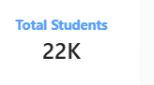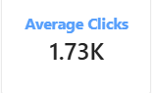
Q2 | How many students passed and how many dropped out? | 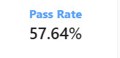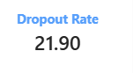
Q3 | How are students spread across engagement levels? | 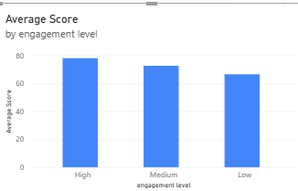
Q4 | How do scores and student numbers differ by performance level? | 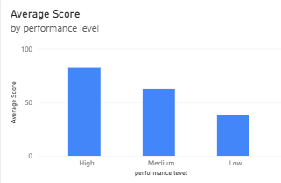
Q5 | How many students are in each risk level? | 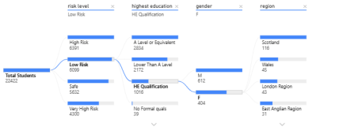
Q6 | How does the number of clicks relate to the average score? | 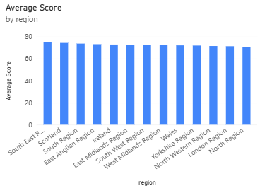
Q8 | Which engagement levels have the highest dropout rate? | 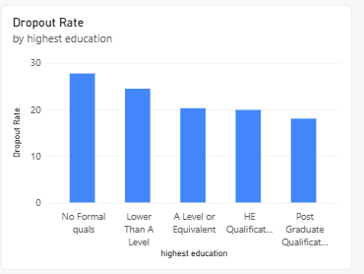

4.2 Developing Visualizations
No. | Visual | Chart type | Fields and measures
V1 | Engagement Level Distribution | Donut chart | Engagement level; distinct count of id student
V2 | Performance Level Analysis | Column chart | Performance level; students; average avg score
V3 | Risk Level Distribution | Donut chart | Risk level; distinct count of id student
V4 | Engagement vs. Performance | Clustered column | Engagement level; average avg score; students
V5 | Total Clicks vs. Average Score | Column or line | click band; average avg score; students
V6 | Dropout Rate by Engagement Level | Bar chart | Engagement level; dropout students; dropout rate (%)
V7 | Performance vs. Dropout | Bar chart | Performance level; dropout students; dropout rate (%)
V8 | Regional Analysis | Map or bar, with table | region; students; average avg score; average total clicks
V9 | Educational Background Analysis | Table or bar | Highest education; students; average avg score; average total clicks

5. Dashboard 5.1 Dashboard Design
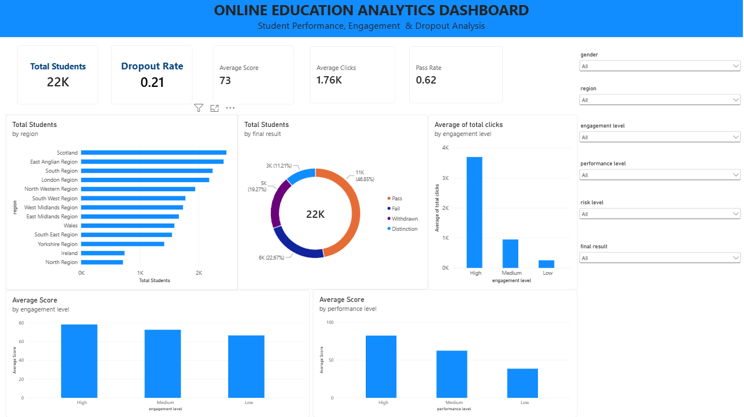

Layout: the top row holds five KPI cards (Total Students, Average Student Score, Average Total Clicks, Students Passed, Students Dropped Out), followed by a row of five slicers. Below are the engagement, performance and risk visuals, then the engagement-vs-performance and clicks-vs-score charts, the two dropout charts, and finally the regional and educational background views.

KPI Cards

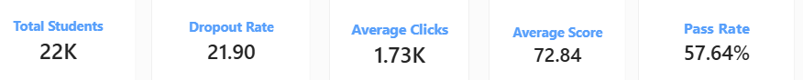

6. Report
6.1 Report 1
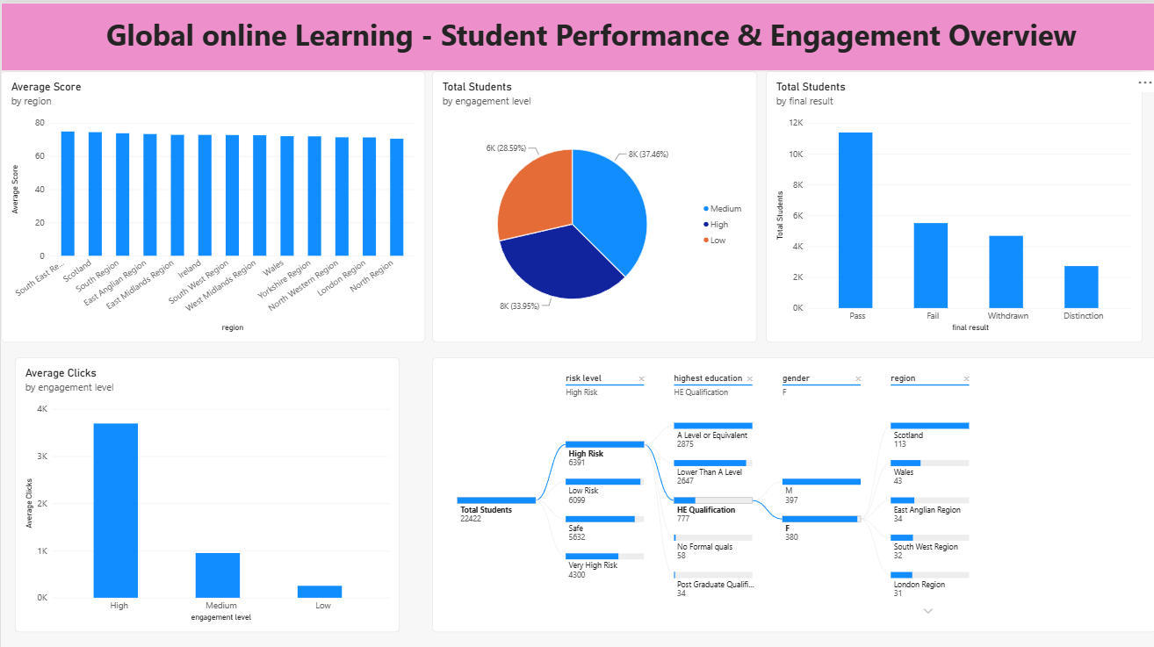

6.2Report 2
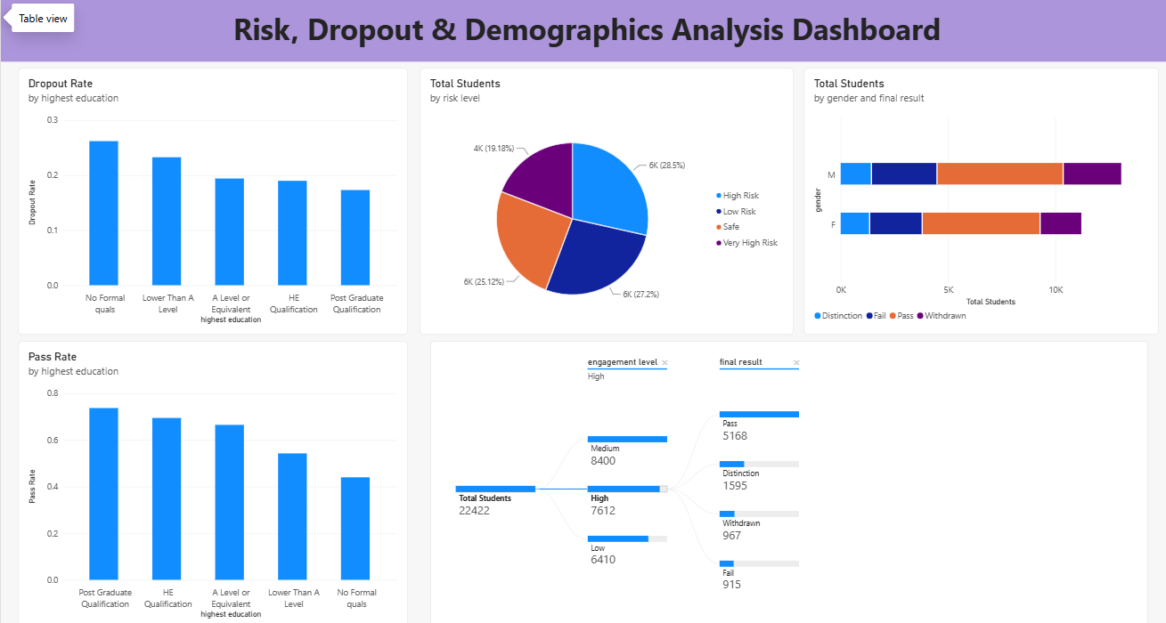

7. Performance Testing

7.1 Utilization of Data Filters
No. | Filter (slicer) | Field | Applies to
1 | Region | region | All visuals
2 | Educational background | Highest education | All visuals
3 | Engagement level | Engagement level | All visuals
4 | Performance level | Performance level | All visuals
5 | Risk level | Risk level | All visuals

Total data filters: 5 slicers.

7.2 No of Calculation Columns/Measures
No. | Name | Type | Logic
1 | Total Students | Measure | Distinct count of id student
2 | Average Student Score | Measure | Average of avg score, rounded to 2 decimals
3 | Average Total Clicks | Measure | Average of total clicks, rounded to 2 decimals
4 | Students Passed | Measure | Count of records where pass flag = 1
5 | Students Dropped Out | Measure | Count of records where dropout flag = 1
6 | Dropout Rate (%) | Measure | Dropped-out students divided by total students, times 100
7 | Click Band | Calculated column | Groups total clicks into 0-500, 500-1000, 1000-2000, 2000-3000 and 3000+

7.3 No of Visualization
Type | Count
KPI cards | 5
Charts and tables | 9
Slicers | 5

8. Conclusion/Observation
The Online Learning Engagement Analytics solution brings student engagement, performance, risk and dropout into one dashboard and report. It answers the questions raised by the customer problem statements: instructors can see which engagement levels lose students, and program managers can compare dropout and results across regions and educational backgrounds.
Key observations from the analysis:
Visual ID | Chart Component Name | Placement Location & Logic | Dashboard Live Value / Summary Metrics
V1 | Engagement Level Distribution | Top-Right Donut Chart (Total Students by Platform Activity Level Mapping) | High Engagement Group: Highest Interaction Tracks  Medium Engagement: Mid-level Clicks Profile  Low Engagement Group: Critical Support Pool
V2 | Performance Level Analysis | Center-Left Horizontal Bar Graph (Tracking Total Students by Regional Demographics) | Scotland: Top Enrolment Hub (~2.5K Students)  East Anglian / South Region: Fast Growing Segments  North Region: Smallest Student Concentration
V3 | Risk Level Distribution | Center-Pie Chart Breakdown (Isolating Risk Profiles Across the 22K Student Ecosystem) | High Risk: 28.5% (6,391 Students)  Low Risk: 27.2% (6,099 Students)  Safe Status: 25.12% (5,632 Students)  Very High Risk: 19.18% (4,300 Students)
V4 | Engagement vs. Performance | Bottom-Left Column Chart (Average Score Distribution Indexed by Engagement Level) | High Engagement Grade: ~78 Average Score  Medium Engagement Grade: ~74 Average Score  Low Engagement Grade: ~70 Base Score
V5 | Total Clicks vs. Average Score | Center Column Chart (Average Score Tracked by Performance Level Tier Mapping) | High Performers: ~78 Average Grade Scale  Medium Performers: ~60 Average Grade Scale  Low Performers: ~38 Critical Grade Scale
V6 | Dropout Rate by Engagement | Bottom decomposition branch tree tracks student volumes dropping out. | Highest Loss Category: Low platform interaction paths.
V7 | Performance vs. Dropout | Vertical stacked segment chart tracking gender final pass profiles. | Pass / Distinction Rates: Significantly higher among PG and HE qualification backgrounds.
V8 | Regional Demographics Analysis | Left sidebar bar mapping geographic locations with student counts. | Identifies support target groups in specific regional areas instantly.
V9 | Educational Background Analysis | Center right tree tracking educational background distributions. | Top Demographic: A-Level or Equivalent & Lower Than A-Level paths.

9. Future Scope
• Build a predictive model that flags students likely to drop out before it happens.
• Add course-level and time-based views to see when engagement starts to fall.
• Refresh the dashboard automatically as new activity data arrives.
• Send alerts to instructors when a student moves into a high-risk level.
• Add row-level security so each instructor sees only their own students.

10. Appendix

10.1 Source Code (if any)
SQL queries used for the analysis (table: online education dataset).
1. Total Number of Students
SELECT
COUNT(DISTINCT id_student) AS total students
FROM online_education_dataset;
2. Average Student Score
SELECT
ROUND(AVG(avg score), 2) AS average student score
FROM online_education_dataset;
3. Average Total Clicks
SELECT
ROUND(AVG(total_clicks), 2) AS average_total_clicks
FROM online_education_dataset;
4. Pass and Dropout Analysis
SELECT
SUM(CASE WHEN pass_flag = 1 THEN 1 ELSE 0 END) AS students_passed,
SUM(CASE WHEN dropout_flag = 1 THEN 1 ELSE 0 END) AS students_dropped_out
FROM online_education_dataset;
5. Engagement Level Analysis
SELECT
Engagement_level,
COUNT(DISTINCT id_student) AS total_students
FROM online_education_dataset
GROUP BY engagement_level
ORDER BY total_students DESC;
6. Performance Level Analysis
SELECT
Performance_level,
COUNT(DISTINCT id_student) AS total_students,
ROUND(AVG(avg score), 2) AS average score
FROM online_education_dataset
GROUP BY performance_level
ORDER BY average_score DESC;
7. Risk Level Analysis
SELECT
Risk_level,
COUNT(DISTINCT id_student) AS total_students
FROM online_education_dataset
GROUP BY risk_level
ORDER BY total_students DESC;
8. Engagement vs. Performance
SELECT
Engagement_level,
ROUND(AVG(avg score), 2) AS average _score,
COUNT(DISTINCT id_student) AS total_students
FROM online_education_dataset
GROUP BY engagement_level
ORDER BY average_score DESC;
9. Total Clicks vs. Average Score
SELECT
CASE WHEN total_clicks < 500 THEN '0 - 500' WHEN total_clicks < 1000 THEN '500 - 1000' WHEN total_clicks < 2000 THEN '1000 - 2000' WHEN total_clicks < 3000 THEN '2000 - 3000' ELSE '3000+' END AS click_band,
COUNT(DISTINCT id_student) AS total_students,
ROUND(AVG(avg score), 2) AS average core
FROM online_education_dataset
GROUP BY click_band
ORDER BY average_score DESC;
10. Dropout Analysis by Engagement Level
SELECT
Engagement_level,
COUNT(DISTINCT id_student) AS total_students,
SUM(CASE WHEN dropout _flag = 1 THEN 1 ELSE 0 END) AS dropout_students,
ROUND(100.0 * SUM(CASE WHEN dropout_flag = 1 THEN 1 ELSE 0 END) / COUNT(*), 2) AS dropout_rate
FROM online_education_dataset
GROUP BY engagement_level
ORDER BY dropout_ rate DESC;
11. Performance vs. Dropout
SELECT
Performance_level,
COUNT(DISTINCT id_student) AS total_students,
SUM(CASE WHEN dropout _flag = 1 THEN 1 ELSE 0 END) AS dropout_students,
ROUND(100.0 * SUM(CASE WHEN dropout _flag = 1 THEN 1 ELSE 0 END) / COUNT(*), 2) AS dropout_rate
FROM online_education_dataset
GROUP BY performance_level
ORDER BY dropout_rate DESC;
12. Regional Analysis
SELECT
region,
COUNT(DISTINCT id_student) AS total_students,
ROUND(AVG(avg score), 2) AS average score,
ROUND(AVG(total_clicks), 2) AS average _clicks
FROM online_education_dataset
GROUP BY region
ORDER BY total_students DESC;
13. Educational Background Analysis
SELECT
Highest_education,
COUNT(DISTINCT id_student) AS total_students,
ROUND(AVG(avg score), 2) AS average score,
ROUND(AVG(total_clicks), 2) AS average_clicks
FROM online_education_dataset
GROUP BY highest_education
ORDER BY average_score DESC;

10.2 GitHub & Project Demo Link
GitHub repository | https://github.com/Dhanasri130/Online-Learning-Engagement-and-Student-Performance-Analysis

